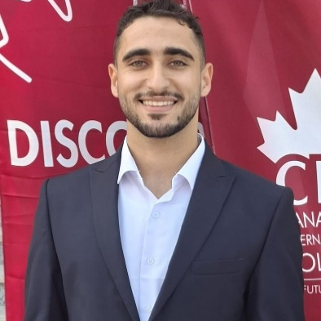

Education
Bachelor’s degree
Business Technology, Canadian international college
Status: Undergraduate (2st Year).

Working experience

Customer service Representative | Xerox

Duration | 6 Months | 2025-6-1 to 2025-12-31
Served as the first point of contact for customers, providing detailed information and guidance.

- Successfully resolved customer complaints and technical issues, maintaining high satisfaction levels.
- Managed data entry and documented customer interactions accurately.
​Sales Specialist | Giga Store (IT Sector)
Duration | 1 year | 2024-5-xx to 2025-6-xx
Provided expert advice to customers on IT hardware and software products.
- ​Achieved sales targets by understanding customer needs and offering appropriate technical solutions.
- Handled after-sales support and technical inquiries.
Freelance Front-End Developer
Developed and maintained responsive web interfaces using modern technologies.
- ​Demonstrated strong time-management skills by delivering projects within deadlines.
- Applied advanced problem-solving skills to troubleshoot bugs and improve user experience.

skills
​ Languages: English (Very Good - B2), Arabic (Native).
​ Technical Excellence: Web Development (Front-End), IT Hardware Troubleshooting, Software
​Typing Speed: 50 Words Per Minute (WPM).
​Soft Skills: Analytical Thinking, Fast Learner, Innovation, Resilience under pressure.
​ Computer Skills: Proficient in Microsoft Office (Word, Excel, PowerPoint).

Summary
A highly motivated and tech-savvy professional with a solid background in Customer Service and IT. Experienced in resolving technical issues and handling customer inquiries, gained through working with Xerox. Currently pursuing a degree in Business Technology, I combine academic knowledge with practical experience in Web Development. Seeking a role at Teleperformance to leverage my English proficiency and problem-solving skills in a professional environment.

Contact
01128391238
abdallahalyawar2004@gmail.com
Giza, Shiekh Zayed, 3rd District, 3rd Neighborhood.
Linkedin.com/in/abdallah-fawzy

Abdallah m. fawzy
call center representive

